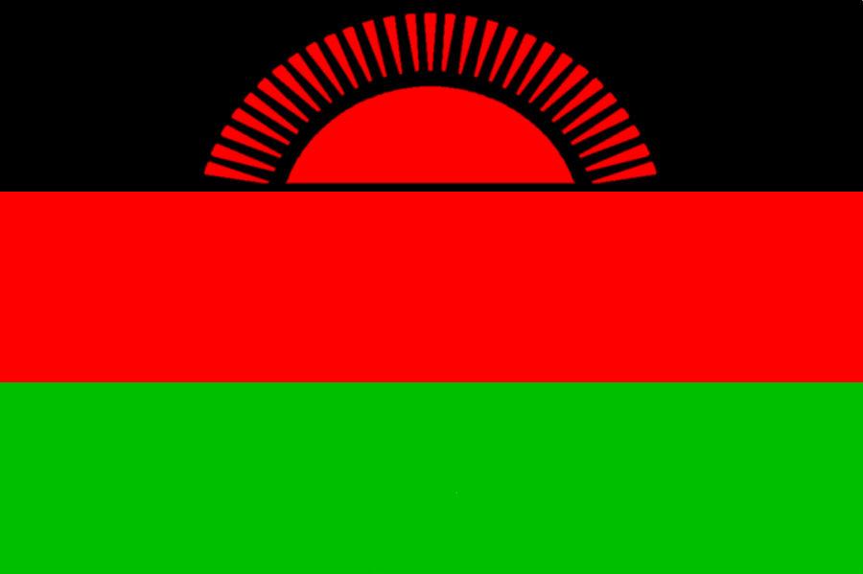

Malawi 2014

Do you...
Enjoy a challenge?
Like exploring new places?
Want to experience new cultures?
Enjoy an adventure?
Like meeting new people?

We are looking for an enthusiastic team of leaders to explore Malawi for three weeks in July 2014 alongside a group of young venturers. This is a fantastic opportunity to experience a vibrant African country and carry out hugely rewarding work which will benefit a local community and work with young people.
Want to know more check out our website at:
www.borders-exploration-group.org.uk/expeditions/malawi
Presentations will take place for prospective leaders at
Selkirk High School on Tue 5th Feb. at 7:30pm
Kelso High School on Tue 12th Feb. at 7:30pm
(Venturer Presentations will take place at later dates)
Application forms available online. Deadline for leader application is February 22nd. Selection weekend will be held on the 1st -3rd March.

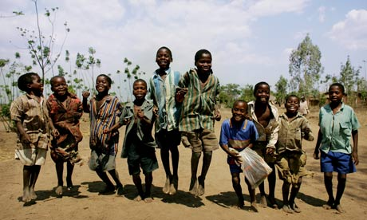
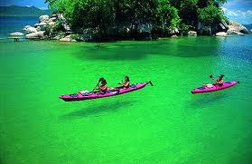

Any queries please email malawi2014@borders-exploration-group.org.uk

